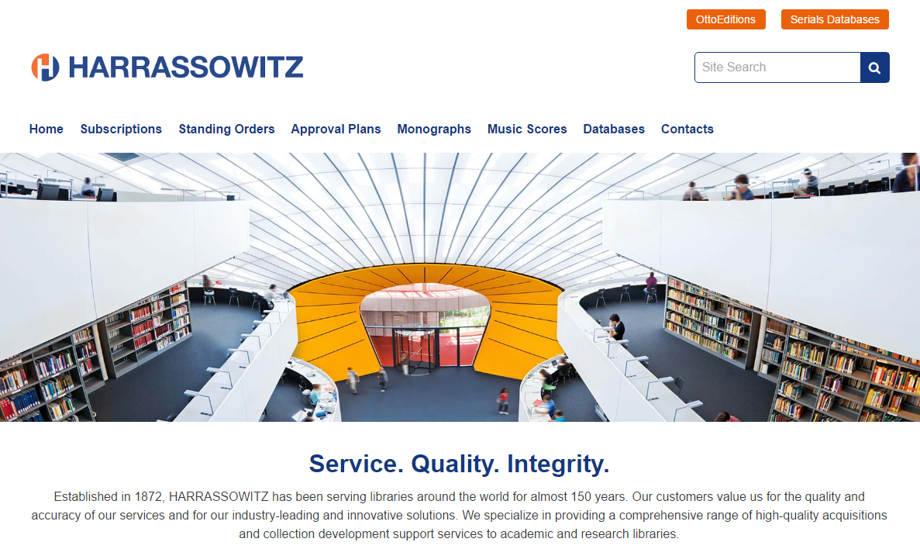
WEBSITE: https://www.harrassowitz.de/
CONTACT: Bill Sherfey - bsherfey@harrassowitz.de

LOGGING IN:
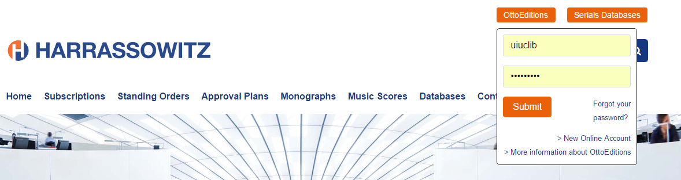

SEARCHING (Simple Search OR Customer Code OR LC Class):
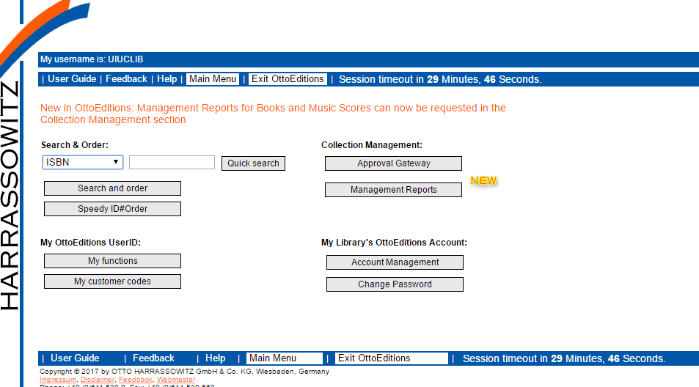

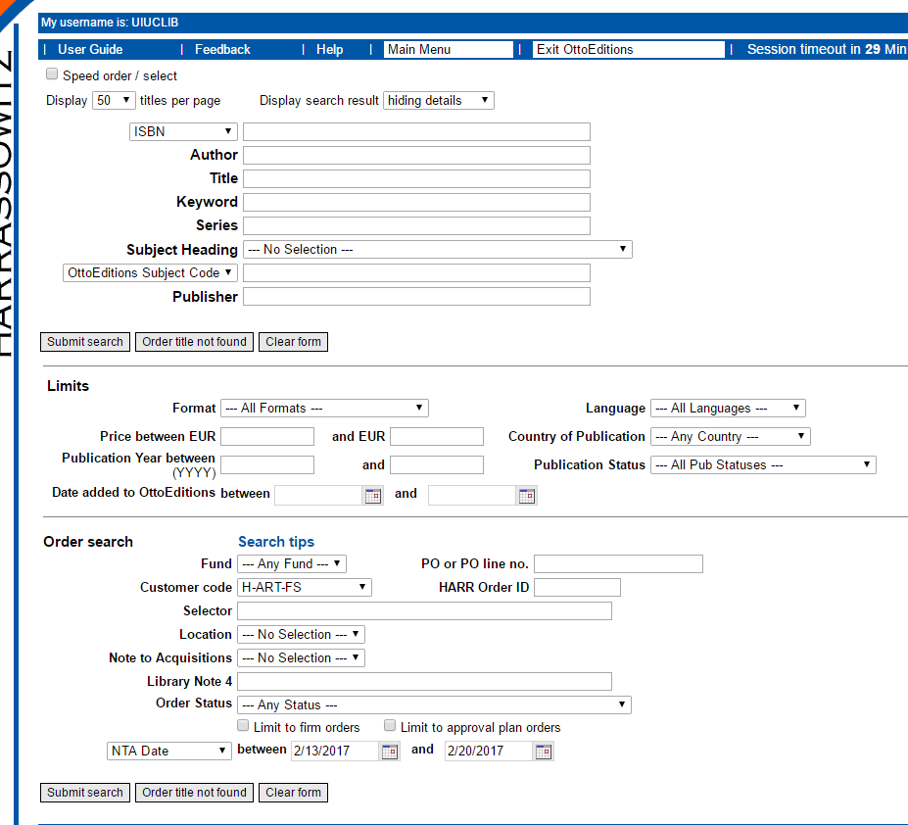
SEARCH…. By Customer Code:

To search by Customer Code:
Enter the appropriate Customer Code with the H-…-FS structure (the others are Blanket Order profiles)
If you do not have a matching H-…-FS Profile, but would like one, please indicate that on your checklist!
H-…-FS Profile | Subject
H-SLAV-FS | Slavic
H-ASTRO-FS | Physics & Astronomy
H-LAND-FS | ACES - Zoology (but NOT Vet Med), Agriculture, Environmental Science)
H-ANGL-FS | English Language, Performing Arts, Theatre, Cinema, Radio, Television
H-MATH-FS | Mathematics
H-MUS-FS  H-SCO-FS  H-SCU-FS | Music (SCO and SCU are for Music Scores)
H-ART-FS | Art
H-GERM-FS | German
H-LING-FS | Paula Carns (Linguistics, Other Germanic Languages, Scandinavian Lanugages)
H-FS | General / Everything Else

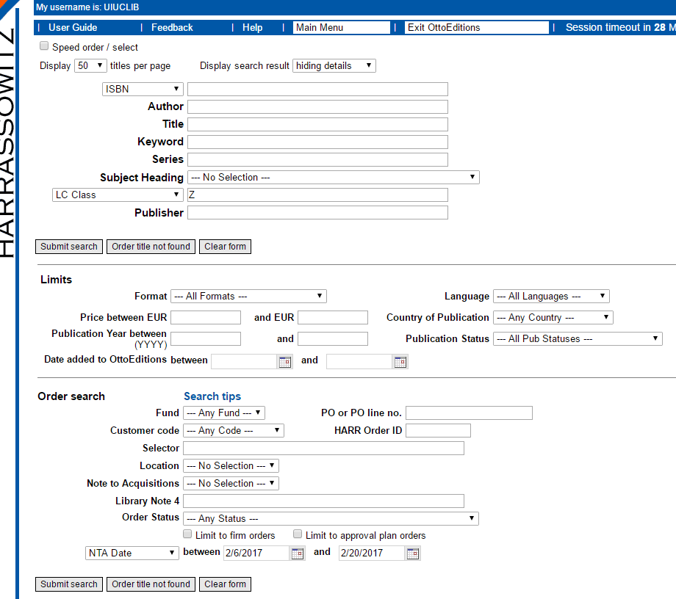
SEARCH…. By LC Class:

ORDERING:
You will see a list of records that appear as follows.
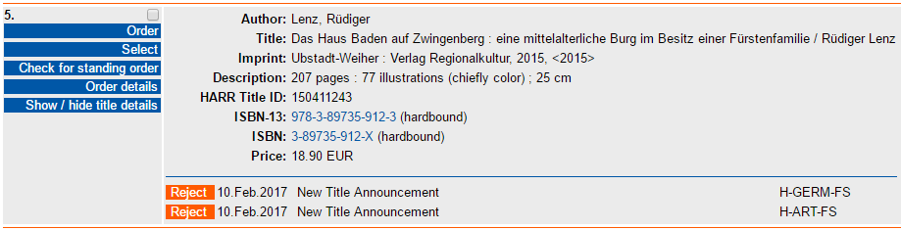
When you locate one you wish to order, on the left-hand side of the record, click Order:

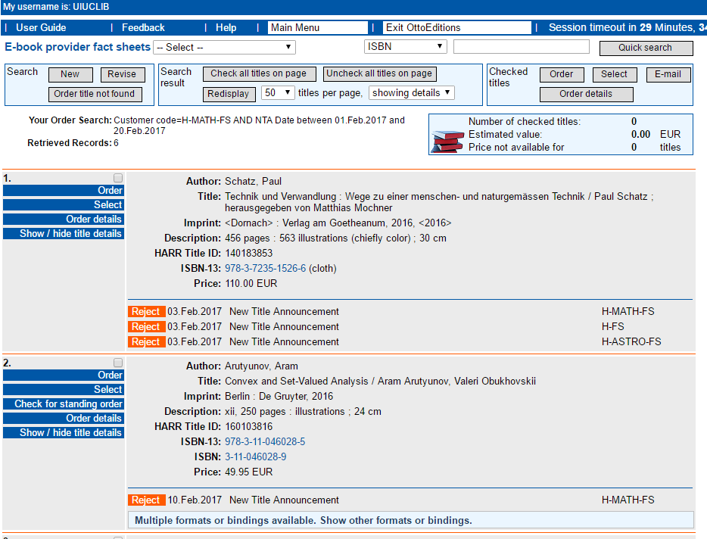
Tip: If you check multiple titles (checkbox above order), then at the very top or very bottom of screen select order, you can enter order details on title after title.

The following screen will appear.
Choose the Customer Code (always use just “H”)
Choose the Fund Code.
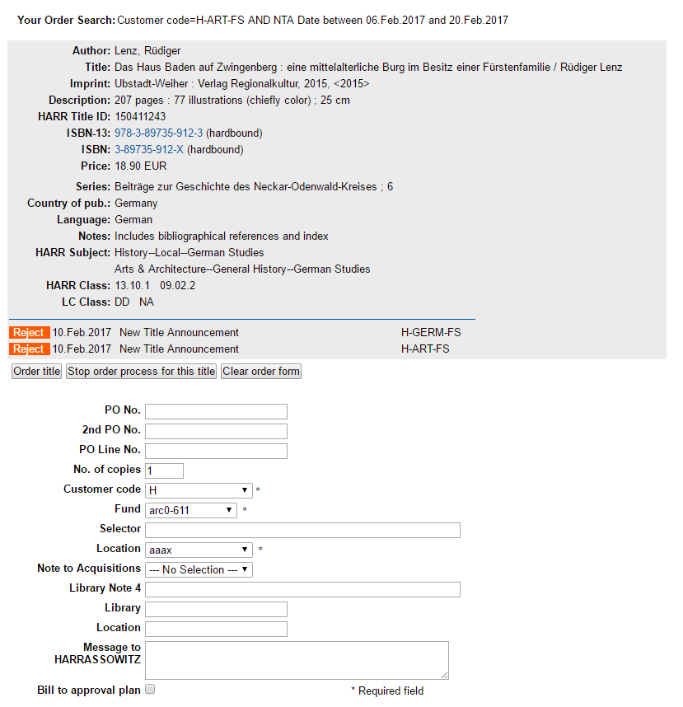
Choose the Location.
From here, you are finished with the process.
Harrassowitz generates an FTP file of pending orders, and sends Acquisitions an e-mail notifying us.

