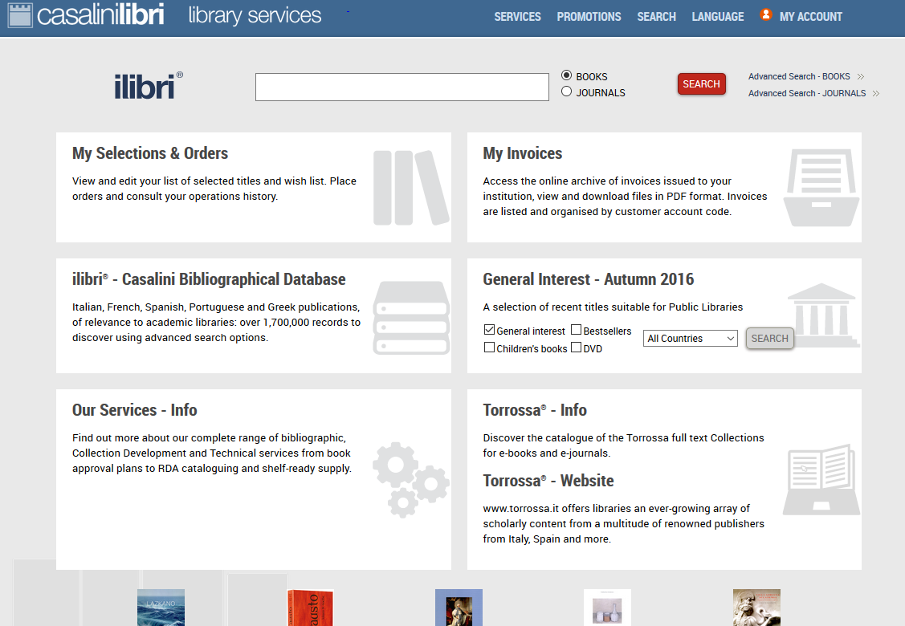
WEBSITE: https://libraries.casalini.it/
CONTACT: Patricia O’Loughlin – patricia.oloughlin@casalini.it

LOGGING IN:
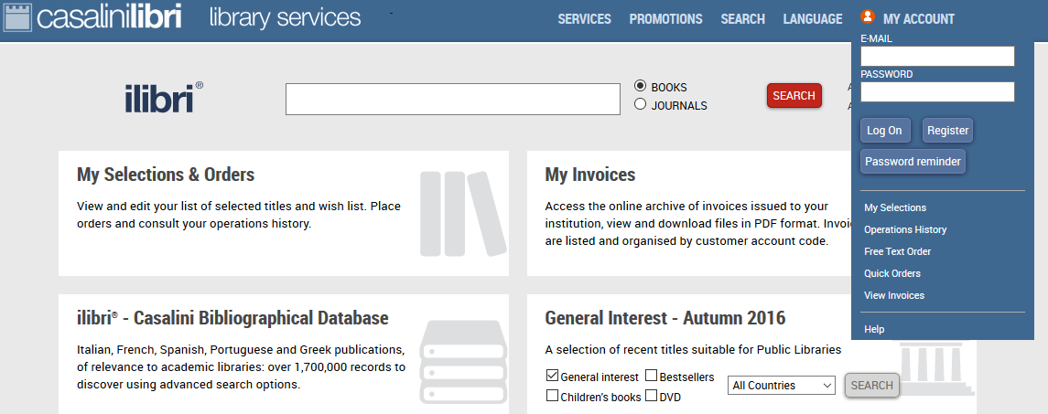
Click in upper right corner on “My Account” and a login box will drop down:

SEARCHING:
In upper right, click Advanced Search
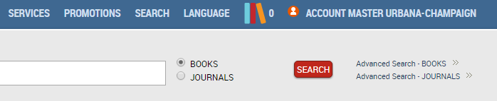

SEARCHING: By “Host Profile” or by call number ranges.

Search by “Host Profile” (will match your name, if you have one, or we can have one set up for you).
On the right can choose “Weekly” group or “Monthly group.”

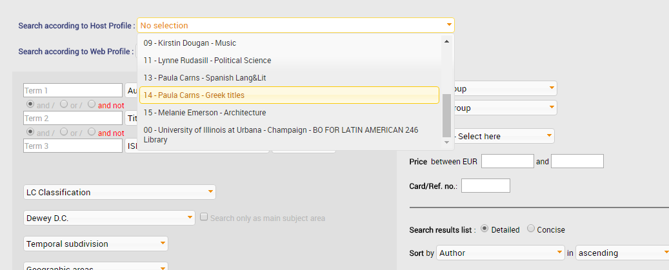

ORDERING
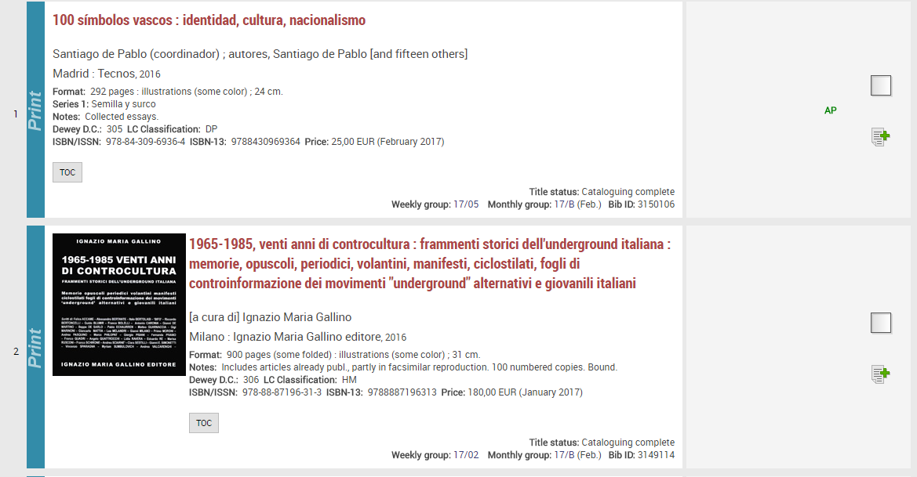
Your list of results will appear as follows:

The “AP” is an example of an order status, indicating that this title would not need to be ordered, as it is already being shipped on our Approval (Blanket Order) plan.

To order the second title, first click the page icon with the green plus sign. A pencil icon will appear.
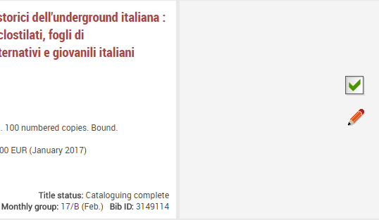

Click the pencil icon to enter order details (or wait until you reach the Manage Selections step)
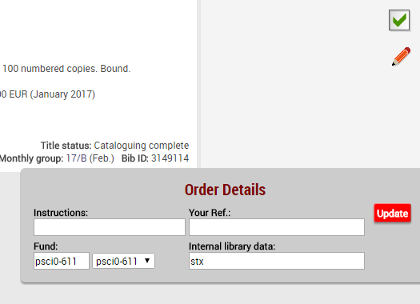
Fund Code:
Only the Fund Code is available as a drop-down due to limitations of Casalini’s system on their side.
Internal library data:
Use to indicate the item’s intended location. This will generate a note in the Purchase Order for Acquisitions staff update the location code.
Otherwise, the default location generated by Voyager is Main Stacks.

After you have entered Order data, click “Manage Your Selections” (top or bottom right corner of screen):
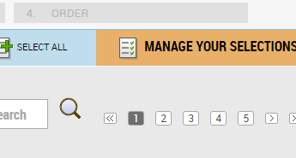

You will be taken to your list of selected titles.
As you can see, fund codes and location (in Internal Library Data) can be added here, as well.
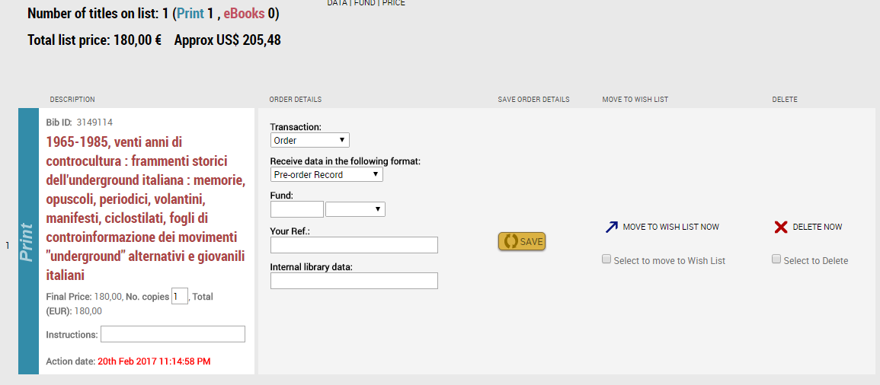

Then click “Notify Account Master” to generate an e-mail letting Acquisitions know you have pending orders (also top or bottom right corner of screen):
