CAPT Minutes
October 31, 2024

Attendance: Tom Teper, John Laskowski, Michael Norman, Seth Robbins, Jennifer Teper, Mary Ton, Stephanie Baker, Angela Waarala,

Note taker: Hannah Williams

- Approve agenda and minutes
  - Agenda and minutes approved.

- Quarterly working group reports

- Search, Discovery, and Delivery Working Group Report – Michael Norman -- October 31, 2024
- We put out a call to the Library for new members to join the Working Group to replace a couple individuals who have left over the past year and got three submissions. The Working Group recommends we add all three to our membership: Sarah Park, Jenny Johnson, and John Rutherford.
- Did a demo at our last meeting of a new version of Easy Search to incorporate the Primo Central Index into the Articles bento section. See the Easy Search demo version here to see this in action: https://libeasysch19dev.library.illinois.edu/discovery/splitsearch.asp?searcharg=ethics+in+engineering&typeofsearch=keyword&OPERATE=GO&selection=devtest
We will continue the discussion on the best ways to pull Primo Central Index results into Easy Search.
- In this new test version of Easy Search, also viewed options to pull in I-Share Consortium Catalog results and/or Special Collections results to view in the Catalog (middle) section of Easy Search (same link as above):
https://libeasysch19dev.library.illinois.edu/discovery/splitsearch.asp?searcharg=ethics+in+engineering&typeofsearch=keyword&OPERATE=GO&selection=devtest
- Continue testing many of the changes EBSCO has made to search and linking into the display of results in their various systems and EDS API services.
- Testing the new Primo AI Research Assistant (and Recommender) service. We have added the new AI Research Assistant in a test Primo Catalog Dev version for the Group to explore. The new Primo AI Research Assistant searches the Primo Central Index for abstracts and summaries of articles/e-resources for sources on entered search terms and/or questions and displays 5 relevant articles, books, book chapters, etc. and presented these to the User.
- In the near future (in January 2025), we would like to push out to Library Users access of the Primo Library Catalog Plus (Library Catalog + Primo Central Index of Articles and More) search profile version and we are exploring the most effective ways to make this version of the Primo Catalog available for Library Discovery of this overarching search capability.
- In addition, starting in January 2025, we are discussing the best possible way to institute User Testing of both Easy Search and the Primo Library Catalog for undergraduate usage of both systems.
- Reviewing possible creation of a Database Search (and Tab) in the Primo Library Catalog to compare with the Libguides version and see if this could be maintained easier in Alma/Primo.
- Reviewing creation of a Newspaper Articles Search (and Tab) in the Primo Library Catalog (Articles and More).
- Discussed Title II and accessibility to Library content, especially related to Discovery services in the Library and the interaction with publisher and vendor systems.
- Discussed and then added Genre hyperlinks functionality in the Primo Library Catalog and this also allows enabling a Genre Facet to group by genre terms (Fiction, Poetry, Biographies, etc.). This will also allow the User to filter by Genre in the Advanced Search area of the Primo Library Catalog (see screenshots below):
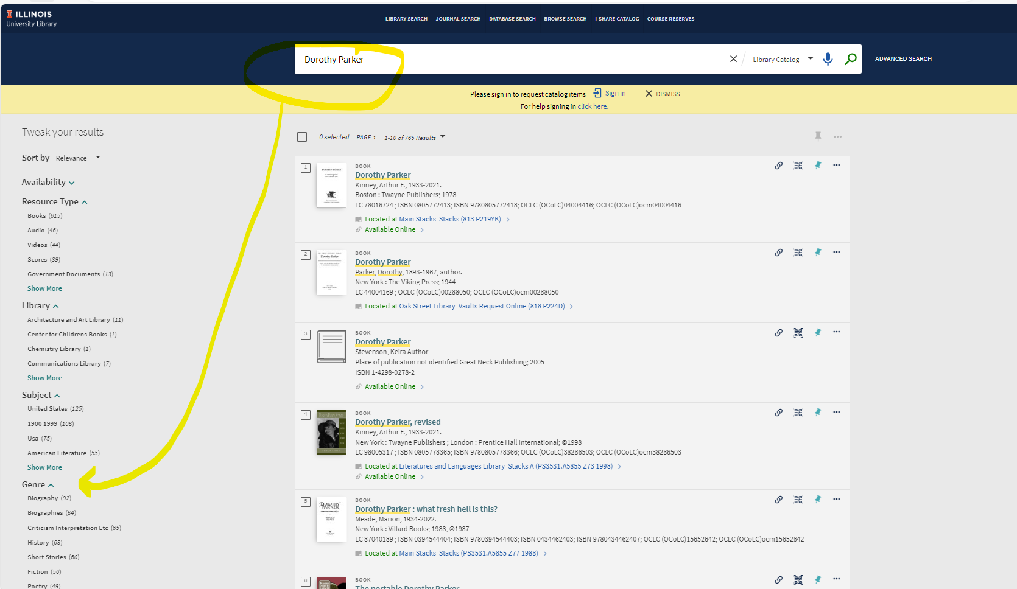
And, the Genre filter in Advanced Search in the Primo Library Catalog:
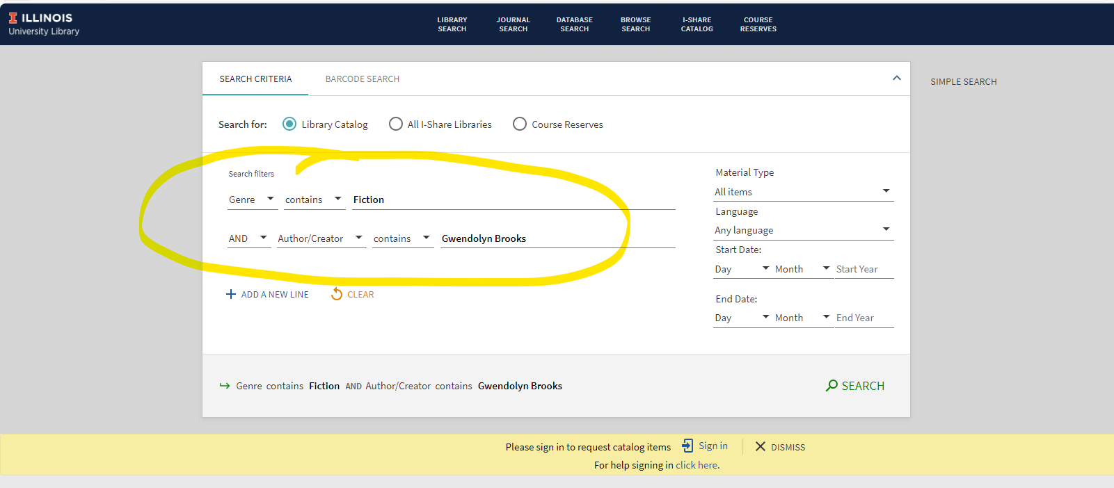

- Web- John Laskowski
- Yali Feng and Jay Heldreth are now members of the team.
- Discussion of global menu for the Library website. It has been 5-6 years since this has been addressed. This needs to be reevaluated in light of technical support, user expectations, space needs, and availability. Discussions will occur about accessibility in relation to the staff site, and they are considering doing an assessment of the new gateway in spring.
- Content on the staff and public sites will be audited with an eye towards identifying things that can be archived or deleted.

- Library Accessibility Program
  - https://uofi.box.com/s/g7frhi6jcyj1h82jjvfdhtbrm8zxla6m.
  - Much of the material is under the purview of the various CAPT working groups, so there will be an assignment of responsibility to these working groups to begin assessing our digital platforms and content and to start developing remediation plans and training materials.
  - Tom has requested any comments on the draft charge in the next week. This topic will likely be introduced at the November all staff quarterly meeting.

- Archon Replacement TF
  - https://uofi.box.com/s/5f4lmb68yhwk99y9y3vjcoap74czkjoy.
  - We do not currently have the resources to locally develop and code a replacement for Archon. The replacement options investigated by the replacement taskforce were largely not ideal, and we are ultimately left with ArchiveSpace. This system does have some interface concerns.
  - There is an overlay for this called ArcLight, and we are developing a task force to being implementation of ArchiveSpace with ArcLight front end.

- Parking lot items-review
  - ADA II (in Nov)

Meeting adjourned at 2:55pm.

Reports by Month
January-Search, Discovery, and Delivery, Web
February-Digital Production, Repositories, Preservation, and Access, LEITC
March-Cataloging and Metadata, Electronic Resources
April-Search, Discovery, and Delivery, Web
May- Digital Production, Repositories, Preservation, and Access, LEITC
June- Cataloging and Metadata, Electronic Resources
July- Search, Discovery, and Delivery, Web
August- Digital Production, Repositories, Preservation, and Access, LEITC
September- Cataloging and Metadata, Electronic Resources
October- Search, Discovery, and Delivery, Web
November- Digital Production, Repositories, Preservation, and Access, LEITC
December- Cataloging and Metadata, Electronic Resources

