Collection Development Committee
Minutes
July 11, 2024

Present: Tom Teper, Cindy Ingold, Jenny Johnson, Paula Carns, Kit Condill, Esra Coskun, Sanga Sung, Mike Dickinson, Wendy Shelburne, Mary Schlembach

Notetaker: Hannah Williams

Agenda/Minutes

Agenda and last month’s meeting minutes approved.

FY25 Budget Discussion
- Review of News from Campus
- Proposed Model
- Final Model
- Calendar

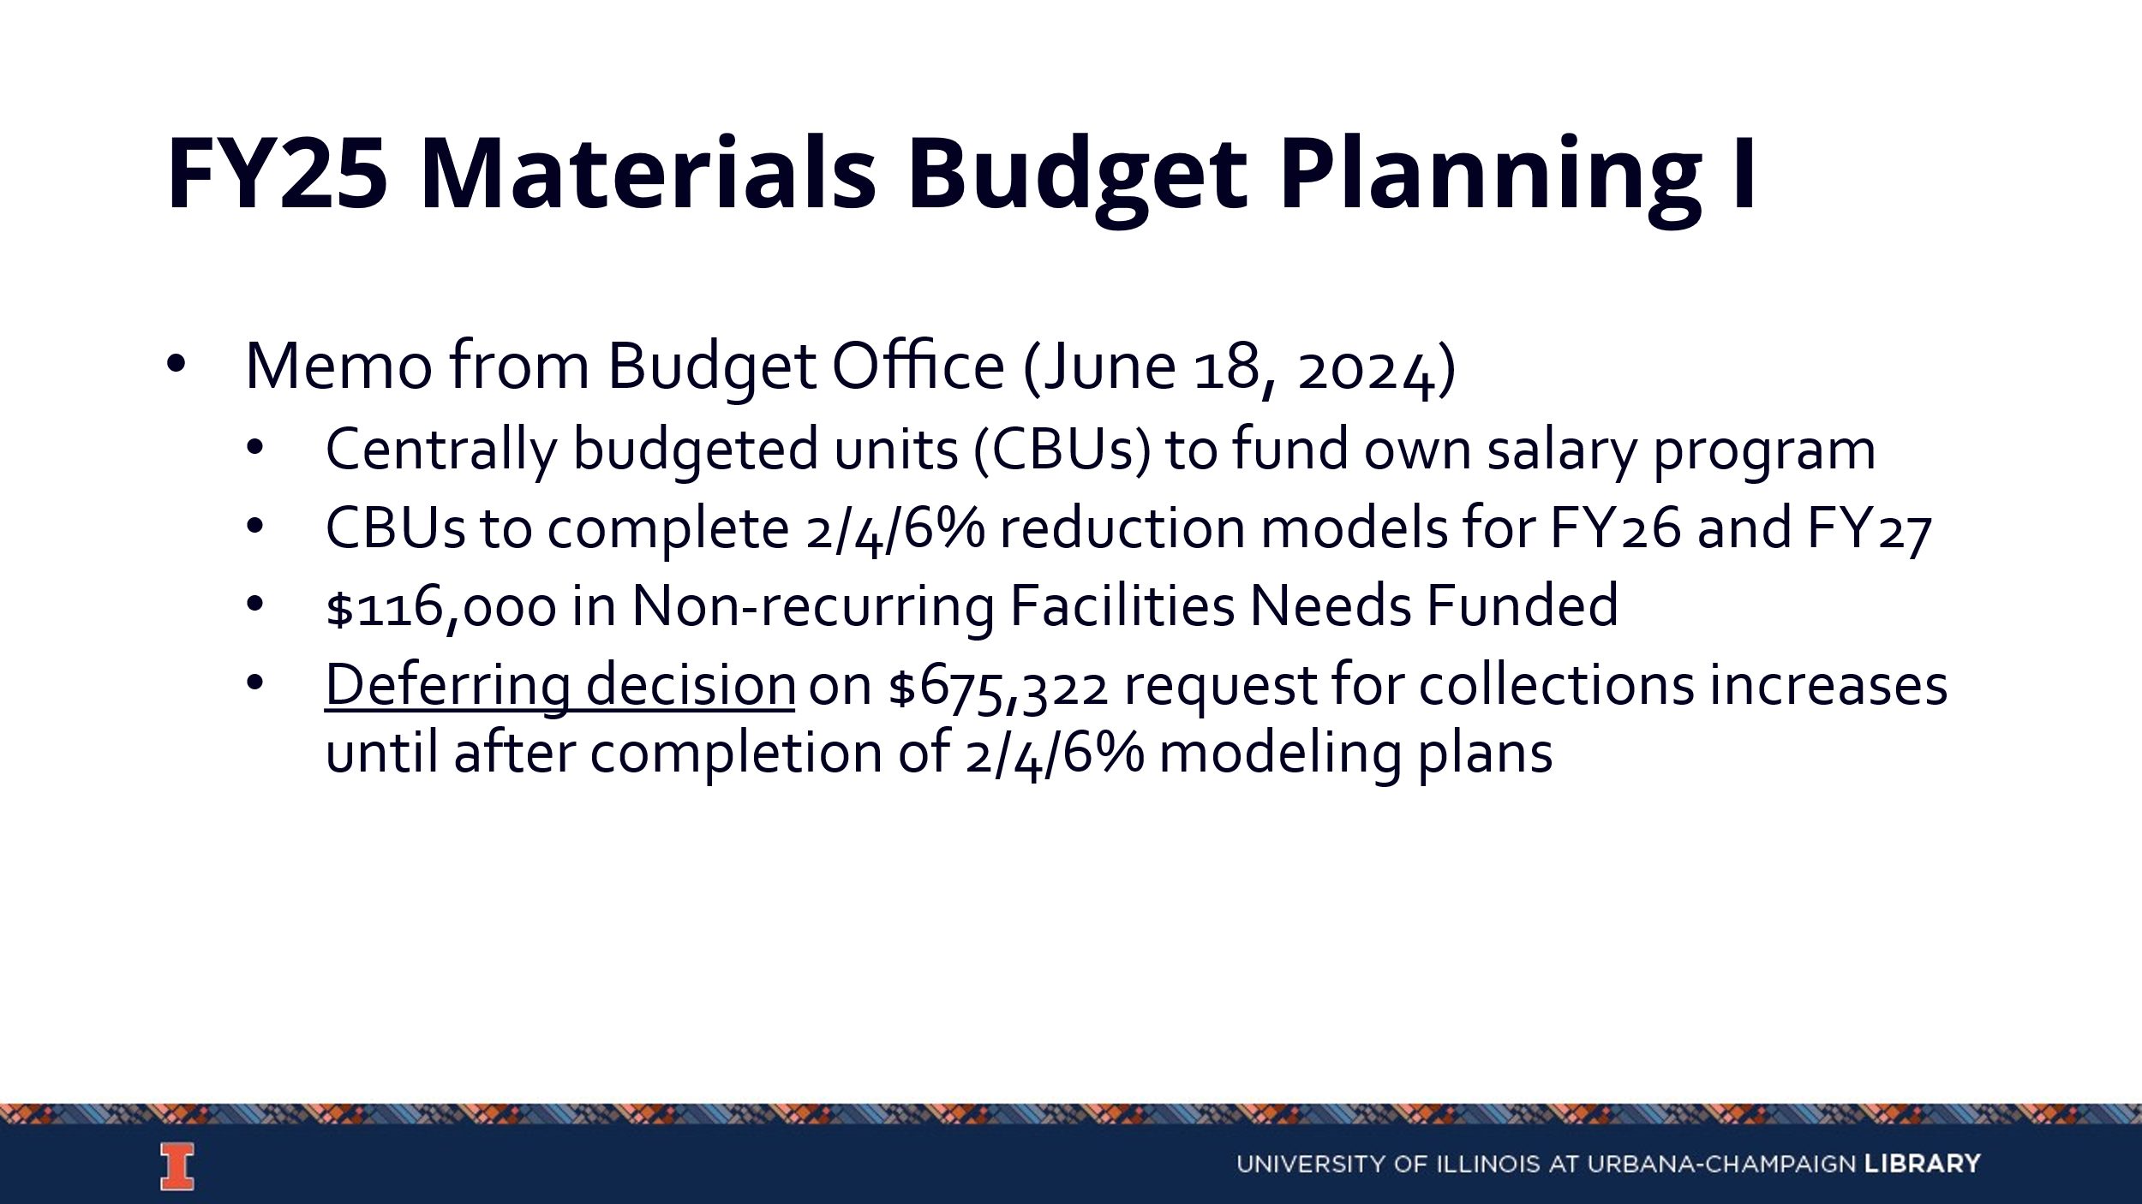

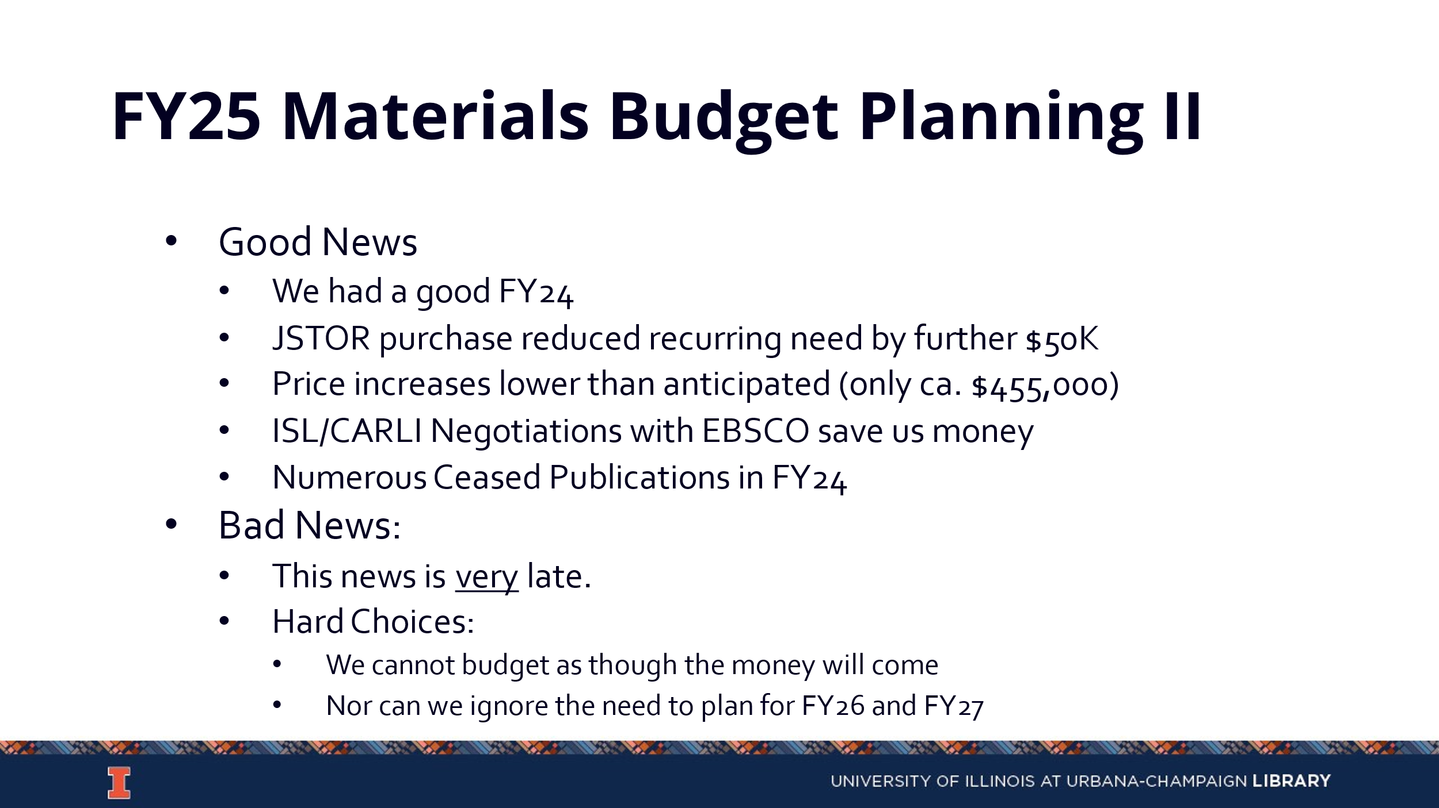

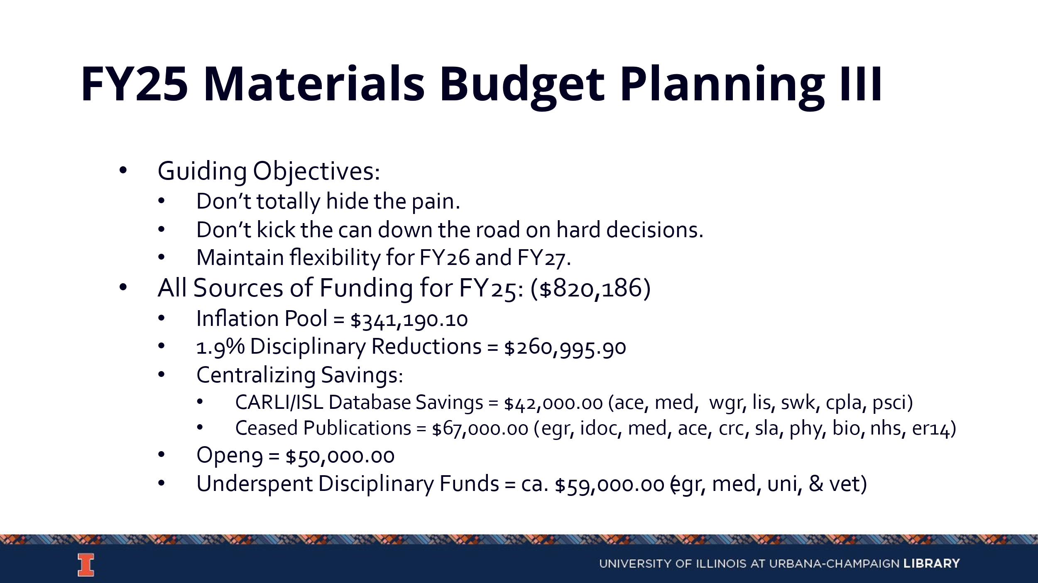

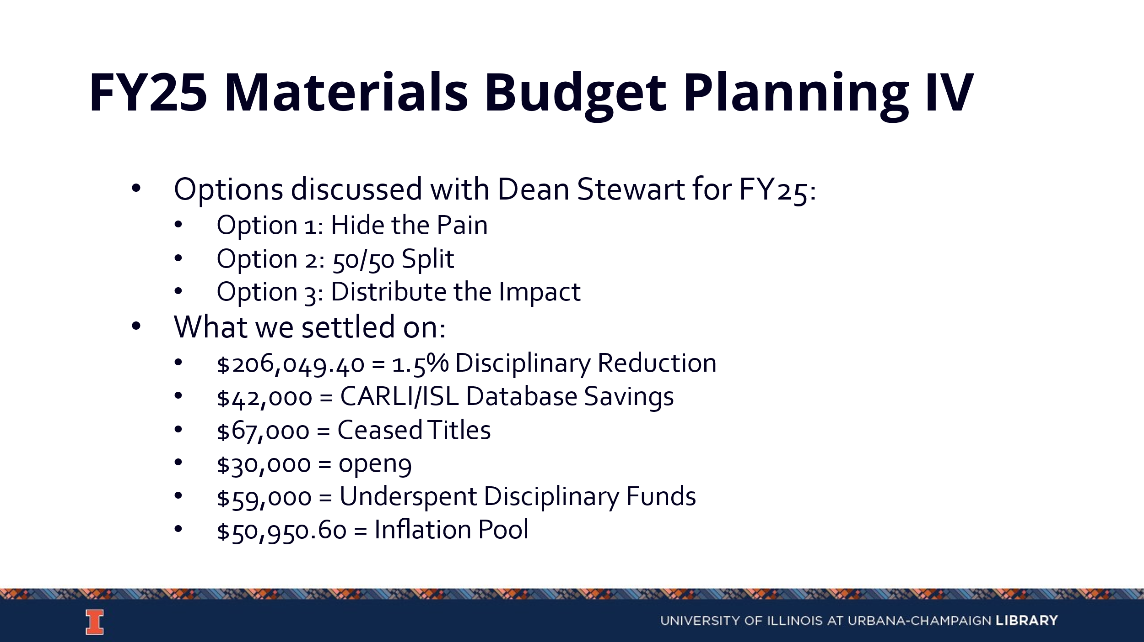

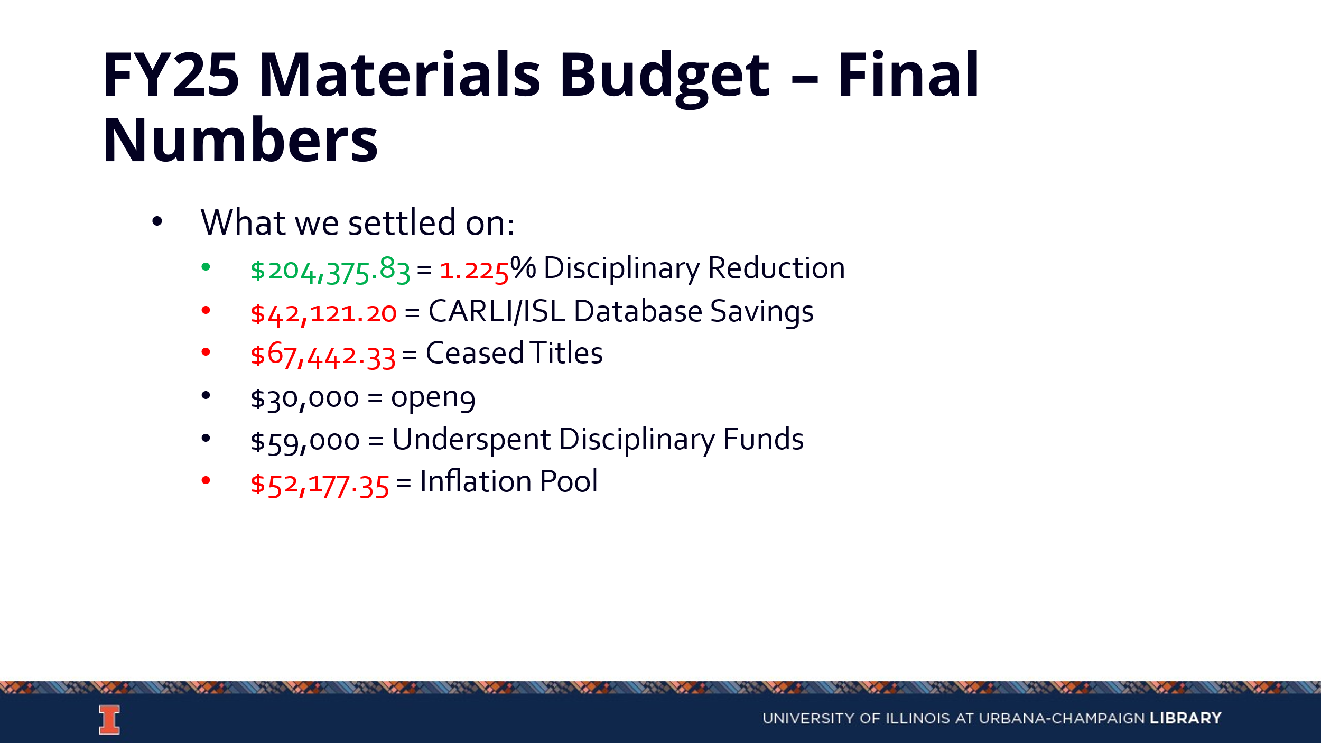
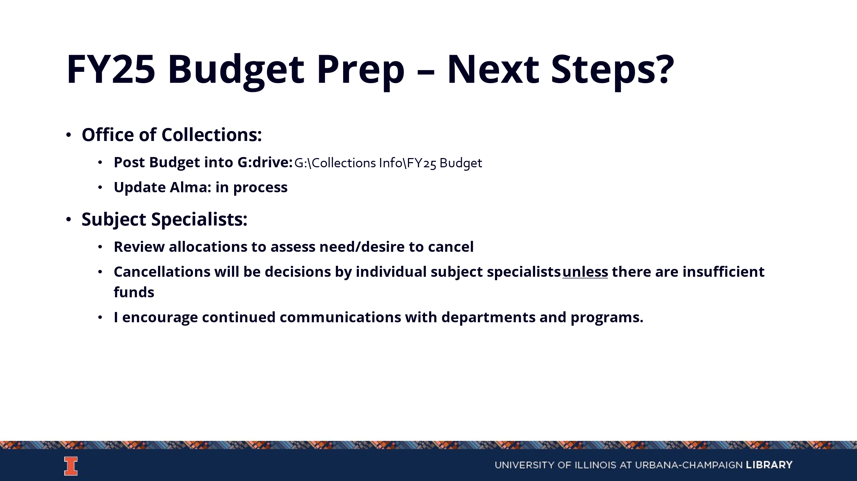
FY26 Plans
- FY27 Budget Planning
  - The goal is to have some reduction decisions made by January in order to give time to discuss with the faculty.
- Gift Policy
  - The current yield on gift materials is only about 20%, which is a very low yield compared to the amount of work put into sorting these materials. We will look into tightening this policy so that fewer materials are taken in.

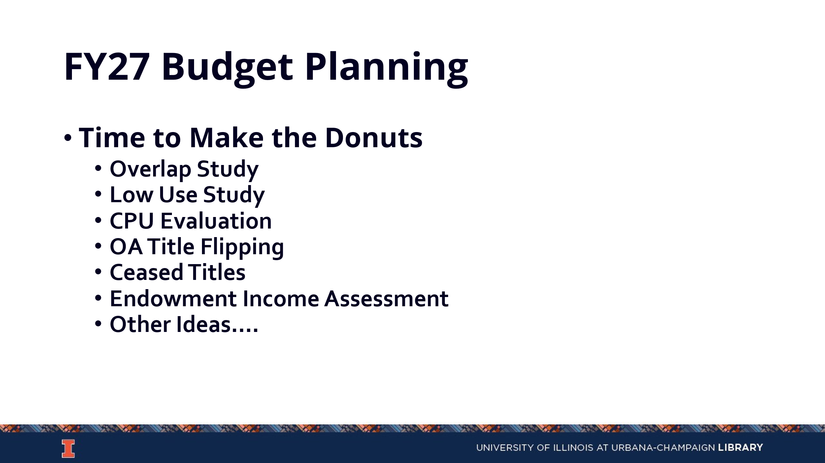

Updates
- Acquisitions -The new acquisitions calendar was sent out and is more robust than previous versions. Questions can be directed to Amy and Wendy.
- E-Resources
- Preservation Services
- BTAA Updates

Meeting adjourned at 3 pm.

