CAPT Minutes
Jan 30, 2025

Present: Tom Teper, John Laskowski, Jenny Maddox Abbott, Michael Norman, Kyle Rimkus, Jennifer Teper, Stephanie Baker, Mary Ton

- Agenda and minutes approved.

- ArchivesSpace update- Kyle Rimkus

  - A number of archivists in the group have been meeting with people at other institutions that have already implemented ArchivesSpace with Arclight.
  - Michigan and Duke have reported that is tends to be a very hands on process of having to manually export a record and then upload it.
  - A big focus for us will be finding ways to streamline this process. We have two instances of ArchivesSpace up and running here.

- Update on ADA II- John Laskowski
- The roadmap proposal for Dean Stewart will be finalized in mid-February. This will be a breakdown of the different aspects of the Library that fall under the Title II requirements and recommendations/action plans for how to make things accessible.
- Communications will send out a monthly email update that will also include tips on making things accessible.
- The campus communications implementation team will be publicizing various workshops that will focus on different tools/environments. These will be published in e-week and other campus communications.
- IT will be holding accessibility related office hours

- Quarterly working group reports

- Search, Discovery, and Delivery- Michael Norman

Search, Discovery, and Delivery Working Group Report – Michael Norman -- January 30, 2025

- The Working Group had a busy last three months. We worked to integrate the Primo Central Discovery Index into the Library’s Discovery Environment, particularly into Easy Search and the Primo Library Catalog. This is something we have been discussing and exploring for the past 1-2 years and through great work by Jay Heldreth, we were able to push these integrations out for Library colleagues to test by the end of the year (December 2024) and pushed over to production versions on January 23 and 24 for Library Users to begin incorporating into their research strategies.
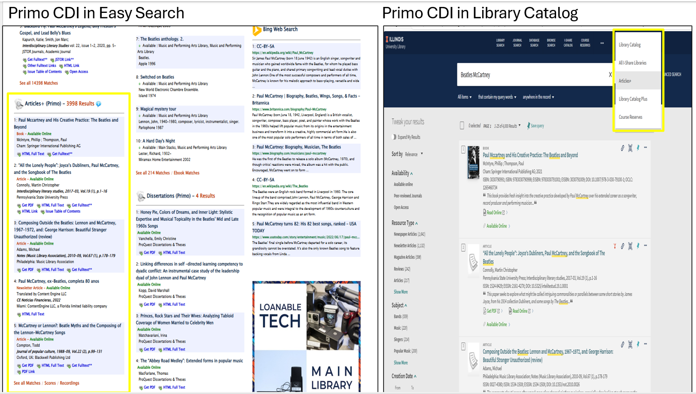
- Ex Libris’ Primo Central Discovery Index (CDI) is a central, unified index, for scholarly and academic material that can be scoped to contain over one billion records of the Library’s electronic and digital collections from many resource types and from thousands of publishers, aggregators, and repositories, including many of the digitized collections in HathiTrust, Biodiversity Heritage Library, Wellcome Library, etc. Many of the EBSCO A&I databases/aggregators were re-introduced into the Primo CDI last year.
- The Library gained access to the CDI back with the I-Share consortium contract for Alma and Primo in 2020, but we did not activate many of its features until this integration this year into Easy Search (using API calls to search the Primo CDI) and the Primo Library Catalog.
- In the Primo Library Catalog, we did also activate as a standalone search the Articles+ (Primo Central Discovery Index) and the Library Catalog Plus search that combines the Library Catalog and Primo CDI
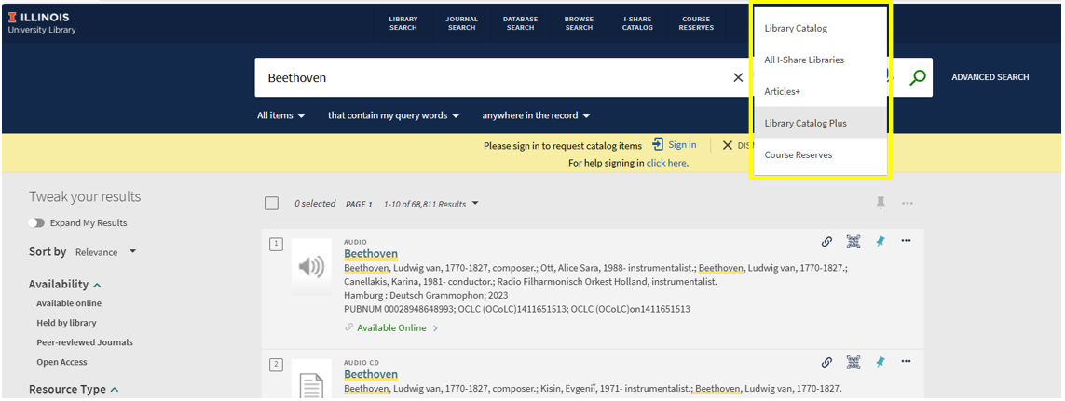
- We did convene three information sessions and two recorded videos in January about the integration of the Primo Central Discovery Index into Easy Search and Primo Library Catalog. We were pleased to see many of our colleagues (around 60 attended the Zoom sessions and over 100 have watched the recordings) who provided good feedback and suggestions for improvements. One function we provided is the ability to click on an information bubble to show the many different formats and resource types that are available in the results.

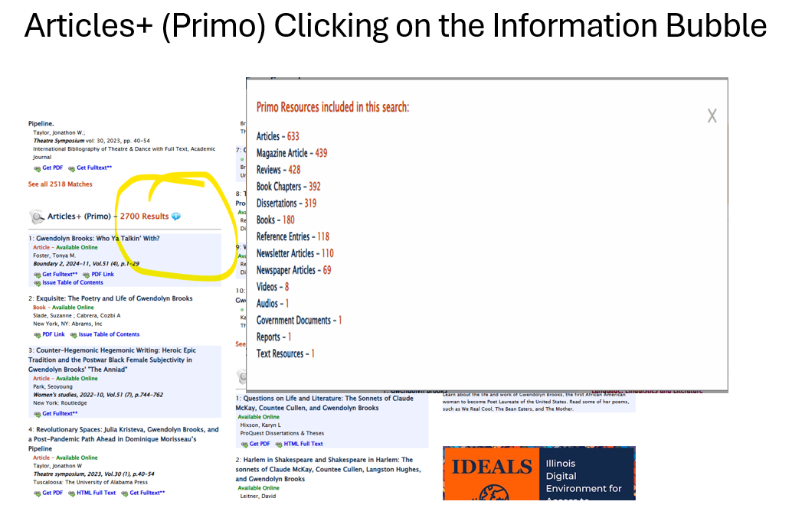

- We will have new information sessions throughout the Spring semester on working with the newly introduced instances of Primo Central Discovery Index, including Hub Training session in February and additional sessions solely concentrating on the integration of the CDI into the Primo Library Catalog. Watch LIBNEWS for those announcements soon.
- In addition, there will be several significant changes to both Discovery systems coming later this summer. One important change is the Library’s cancelling our license for the EBSCO EDS API service that will come this Summer 2025. We won’t lose access to the EBSCO databases but only the additional API service the Library currently licenses solely. This will have an impact on some of the Easy Search sources we target for search results (both in Easy Search Bento and Easy Search Classic instances). The Working Group is continuing to explore the best ways to replace the EDS results (utilizing the Primo Central Index in additional sections in Easy Search and possibly augment with other search/discovery services). We will make available test and dev versions (similar to we did earlier this month) later this Spring Semester to allow all of the Library to help test and familiarize with upcoming changes before pushing out to production. We will have some additional Library-wide information sessions on those changes later this semester as well and we will attend Division meetings over the next two months to discuss Discovery needs to keep us moving forward into the future to provide optimal access to all Library collections.
- We are also working with Heather Murphy and Marisa Modugno to determine best ways to push out to Library Users news about the current changes to Easy Search and the Primo Library Catalog and inform about future changes coming up later this Summer.
- Other important topics the Working Group has been discussing includes the upcoming UX testing of our Discovery Services for undergraduates and beginner researchers. We want to initiate this Spring semester. We will be putting a call to the Library soon for anyone who would like to participate in this User testing and/or any ideas for ways we could successfully do this.
- MJ discussed the possibility of adding structured meta tags to the Primo Library Catalog to allow indexing of these records and holdings in search engines like Google and Bing and make our holdings more discoverable. We will continue exploring these possibilities as some peer research libraries (see Stanford or Indiana University) have their catalog results that appear in these search options.
- Title II accessibility and compliance– This will impact Discovery in many ways. We are examining the VPATs for ProQuest, Ex Libris Primo, and OCLC WorldCat for accessibility issues. There are many additional sites and services that the Library points to for users navigate to that we will need to examine for accessibility compliance as well. In addition, we will be doing a deep dive on the accessibility of Easy Search.

- Web- John Laskowski
- They will be recommending that the staff website be put behind shibboleth. This will still need to be compliant but will be lower priority as the content won’t be discoverable as public.
- They are looking at the navigation for the web, as the dropdowns haven’t been changed since 2018. Orphan pages and outdated templated will also be cleaned up.
- A new public facing accessibility site has been launched.

- Parking lot items-review

Meeting adjourned at 2:18pm.

Reports by Month
January-Search, Discovery, and Delivery, Web
February-Digital Production, Repositories, Preservation, and Access, LEITC
March-Cataloging and Metadata, Electronic Resources
April-Search, Discovery, and Delivery, Web
May- Digital Production, Repositories, Preservation, and Access, LEITC
June- Cataloging and Metadata, Electronic Resources
July- Search, Discovery, and Delivery, Web
August- Digital Production, Repositories, Preservation, and Access, LEITC
September- Cataloging and Metadata, Electronic Resources
October- Search, Discovery, and Delivery, Web
November- Digital Production, Repositories, Preservation, and Access, LEITC
December- Cataloging and Metadata, Electronic Resources

