Collection Development Committee Minutes
December 18, 2024

Present: Tom Teper, Wendy Shelburne, Paula Carns, Cindy Ingold, Jenny Johnson, Esra Coskun, Amy Fry, Kelli Trei, Jennifer Teper, Kit Condill, Mary Schlembach,

Notetaker: Hannah Williams

Agenda/Minutes

Agenda and last month’s meeting minutes approved.

FY25 Collection Development
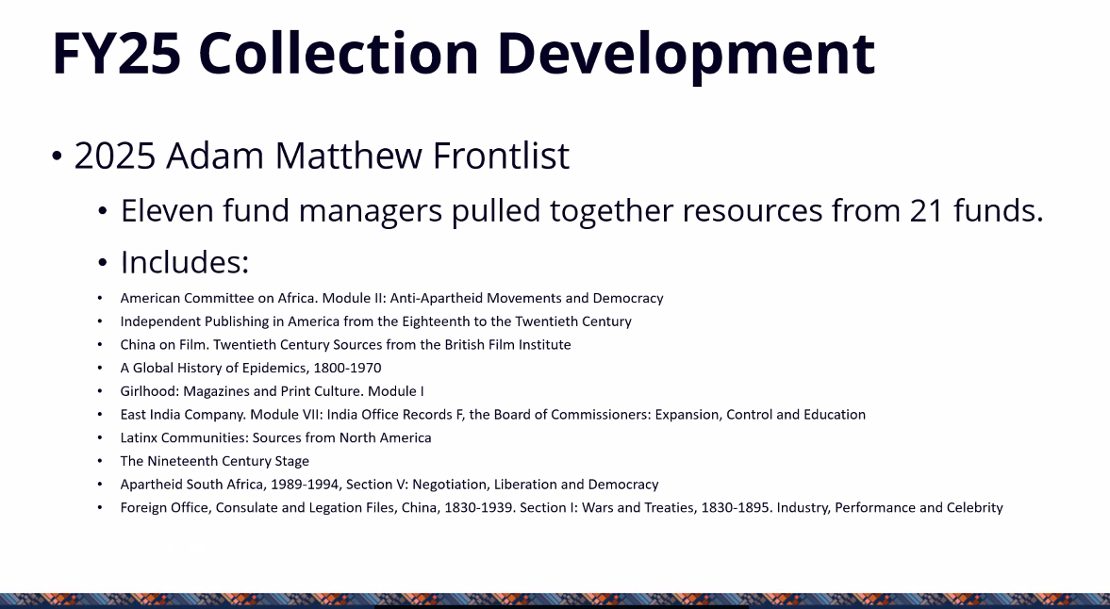

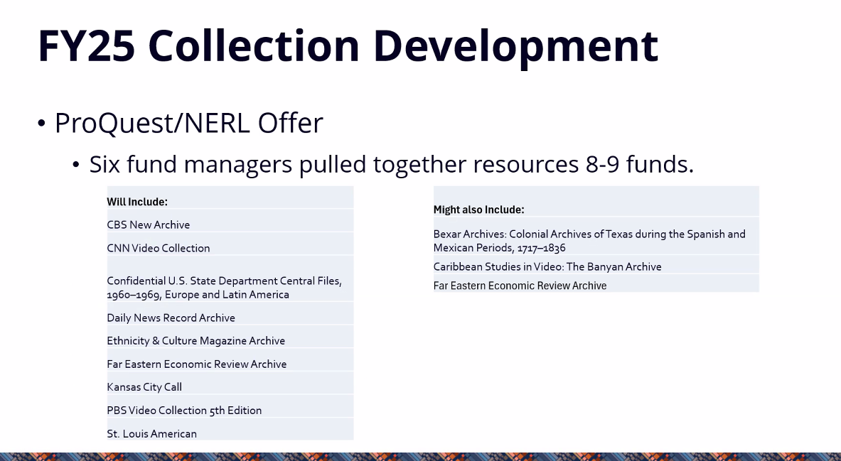

FY26/27 Budget Preparation

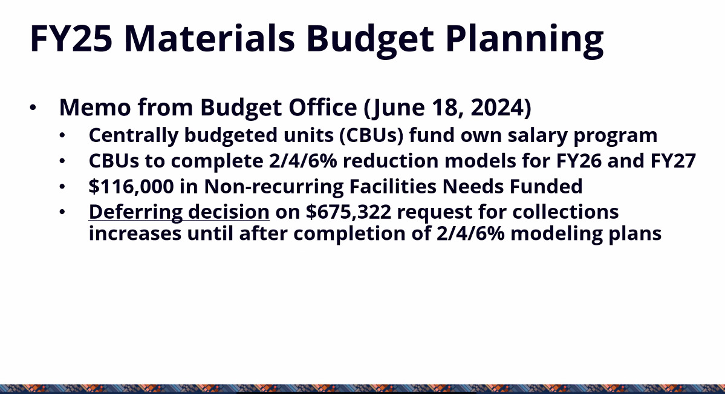

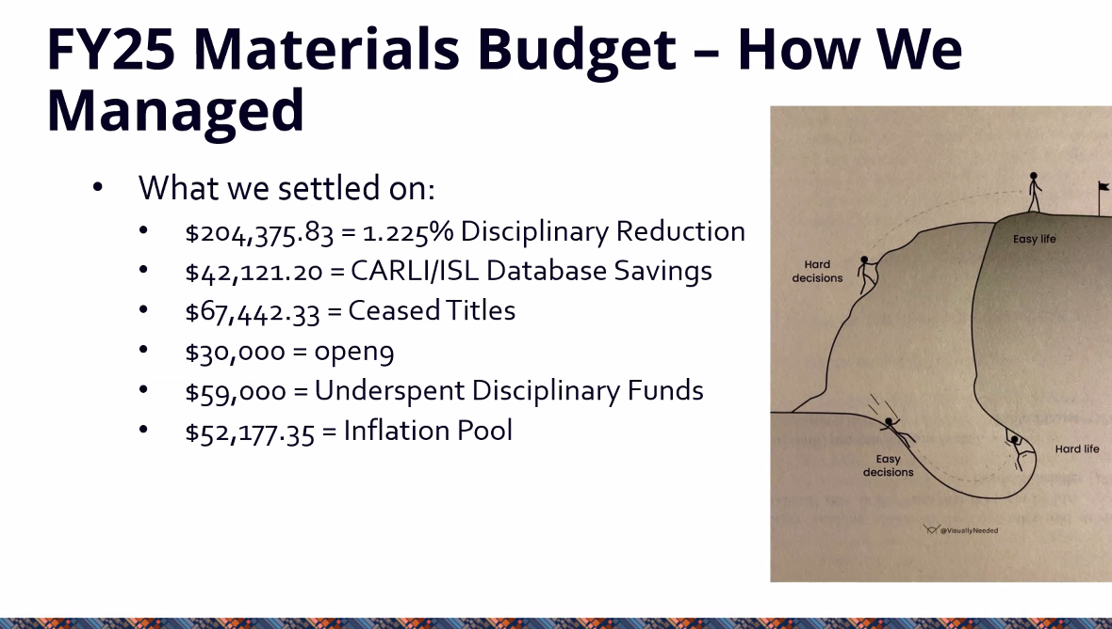

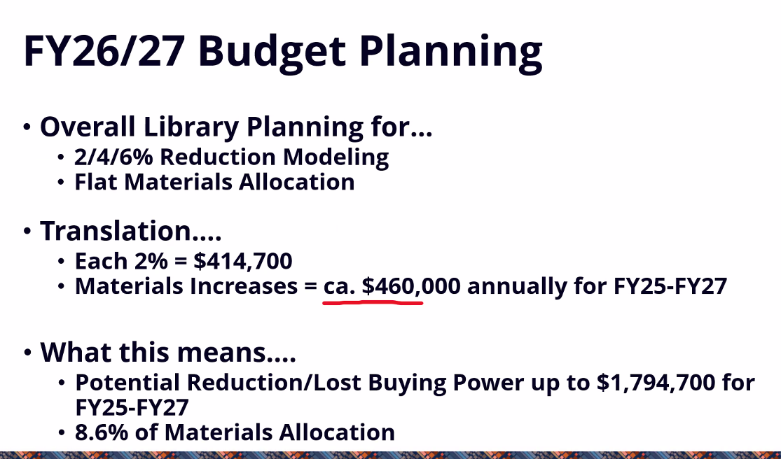

A& I Review
- Working file contains a list of all recurring databases, fund code, and divisions they are under. Esra is adding information about cost per use.
- Group will first be looking at databases over $20,000. Spreadsheets will be provided to each division, and divisions should look at their paid databases and add information to the free databases tab.
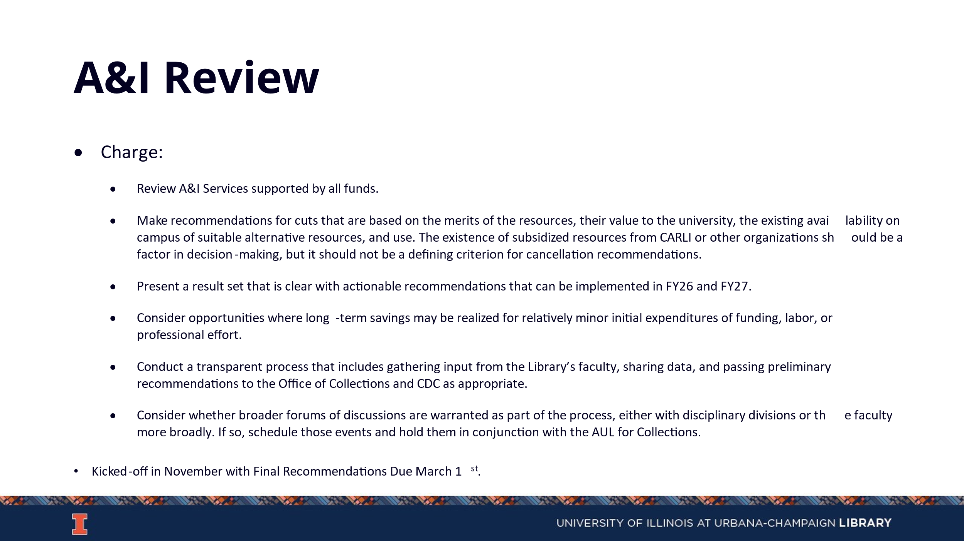

Collection Development Topics
- Talk with division to get feedback about collection development statements. Initial thoughts are to have them but not be publicly available.

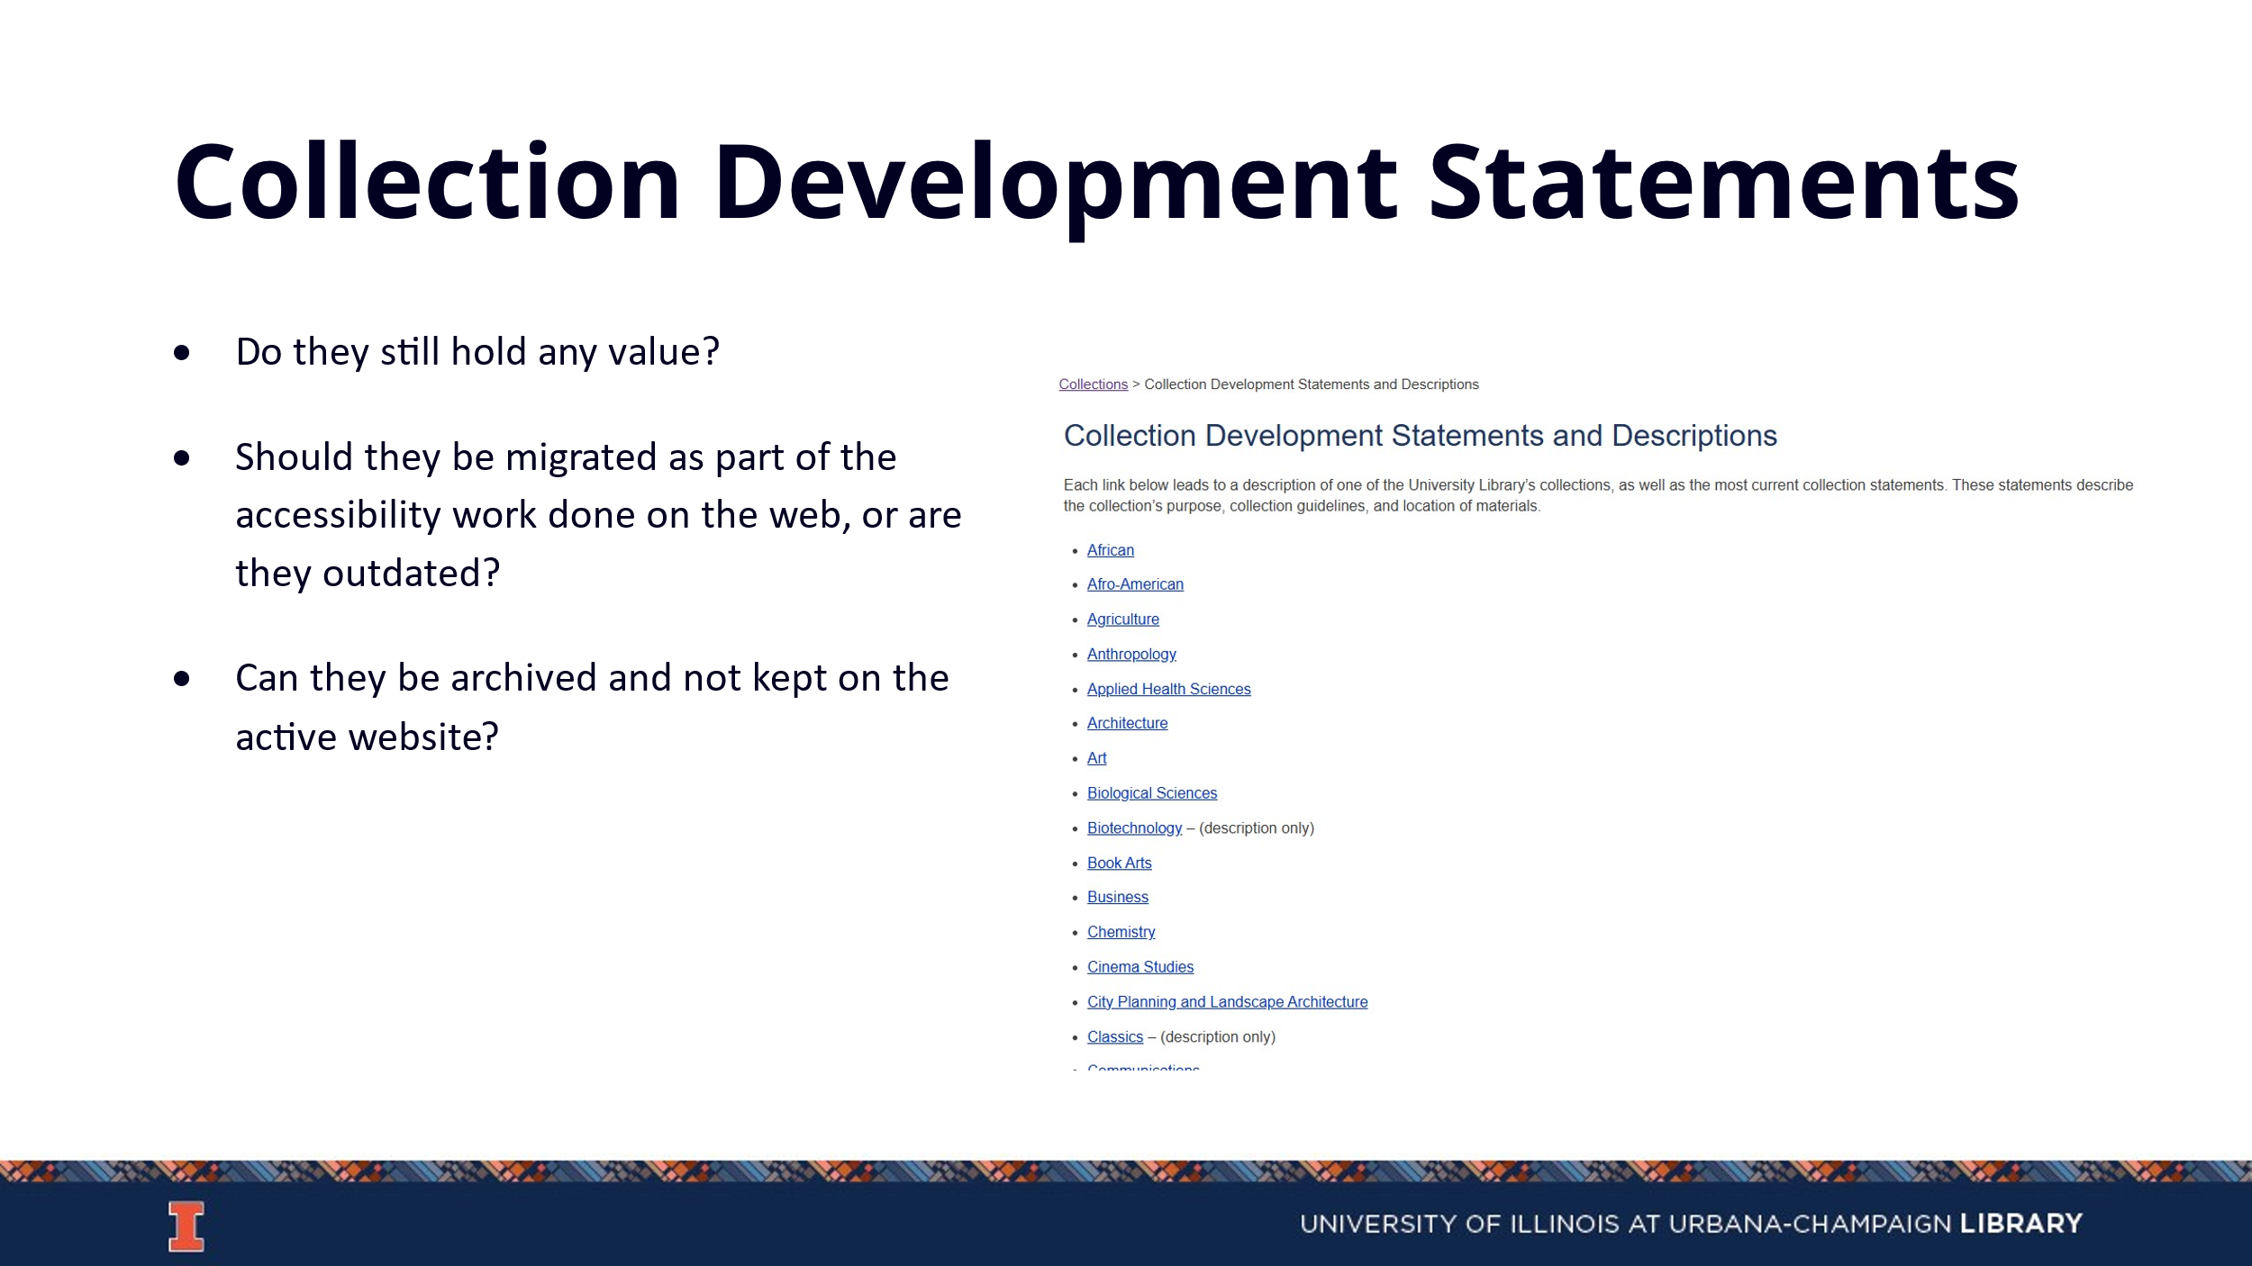

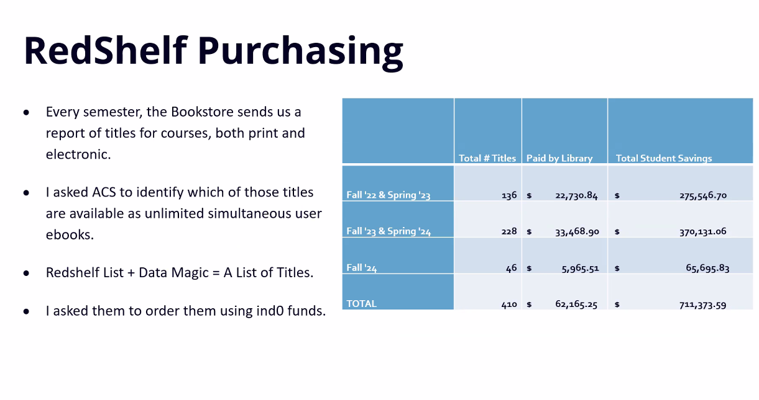

Updates
- Acquisitions Currently short staffed, so please order early and order often.
- E-Resources
- Preservation Services
- BTAA Updates Springer and Nature agreements continue to be worked on. There will likely be an agreement with Springer that contains open access for faculty. Sage will likely be extended for one year with the same terms.

Meeting adjourned at 4:15 pm.

