Collection Development Committee Minutes
August 26, 2024

Present: Tom Teper, Jenny Johnson, Cindy Ingold, Jennifer Teper, Paula Carns, Sanga Sung, Wendy Shelburne, Kit Condill, Mary Schlembach, Kelli Trei

Notetaker: Hannah Williams

Agenda/Minutes

Agenda and last month’s meeting minutes approved.

FY25 Materials Budget Planning

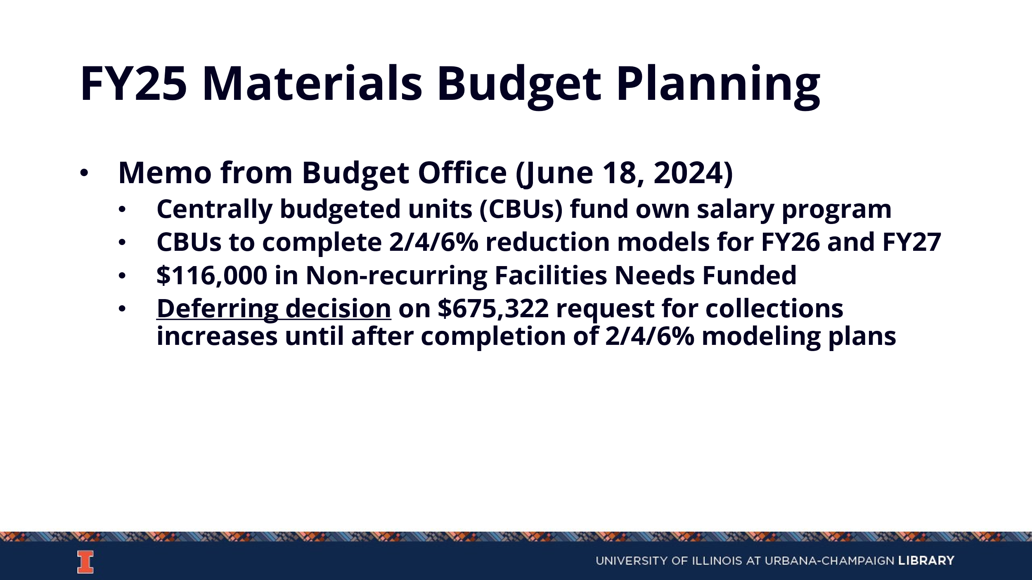

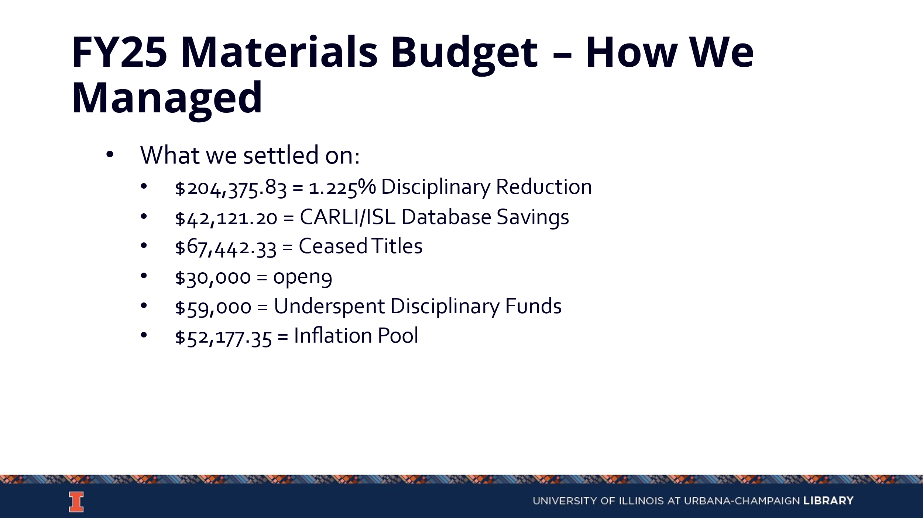
- Between all of the above areas, we were able to cover price increases without mandating any cancellations for the year

FY26/27 Budget Planning
- Review of News from Campus
  - Campus has requested a 2%, 4%, and 6% reduction model for FY26 and FY27

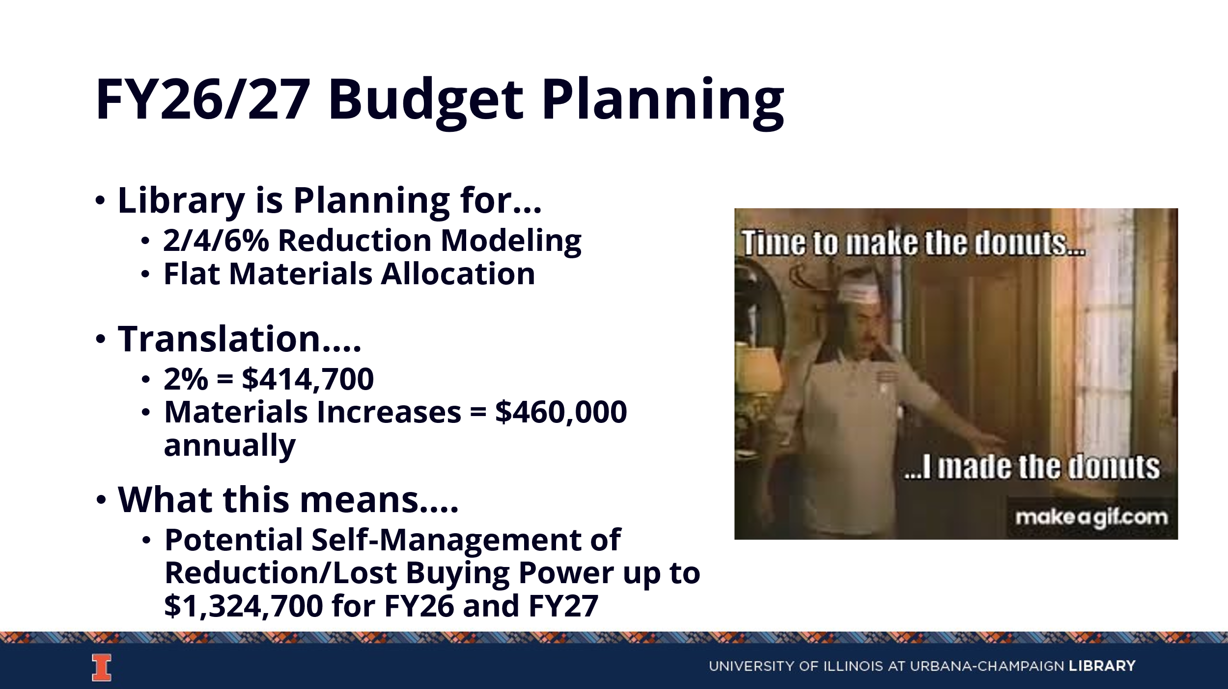

- Proposed Model

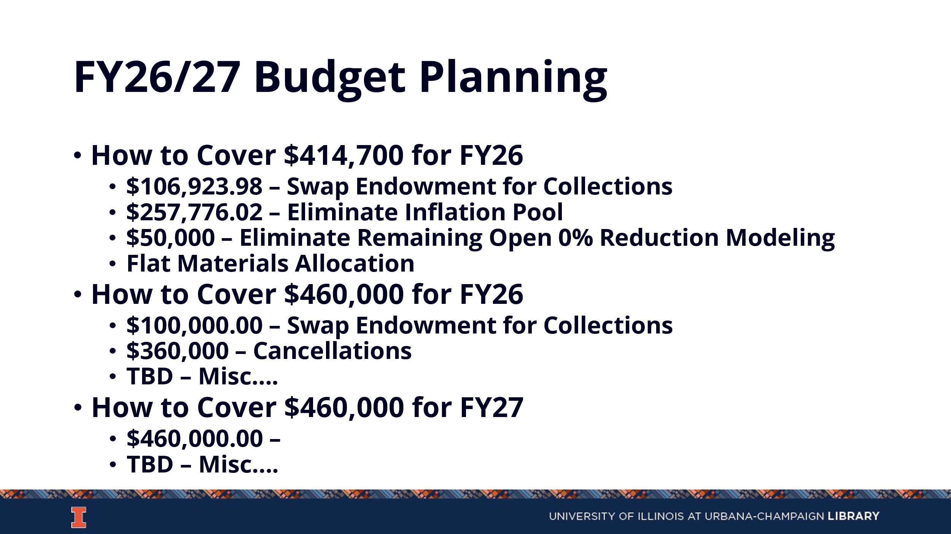
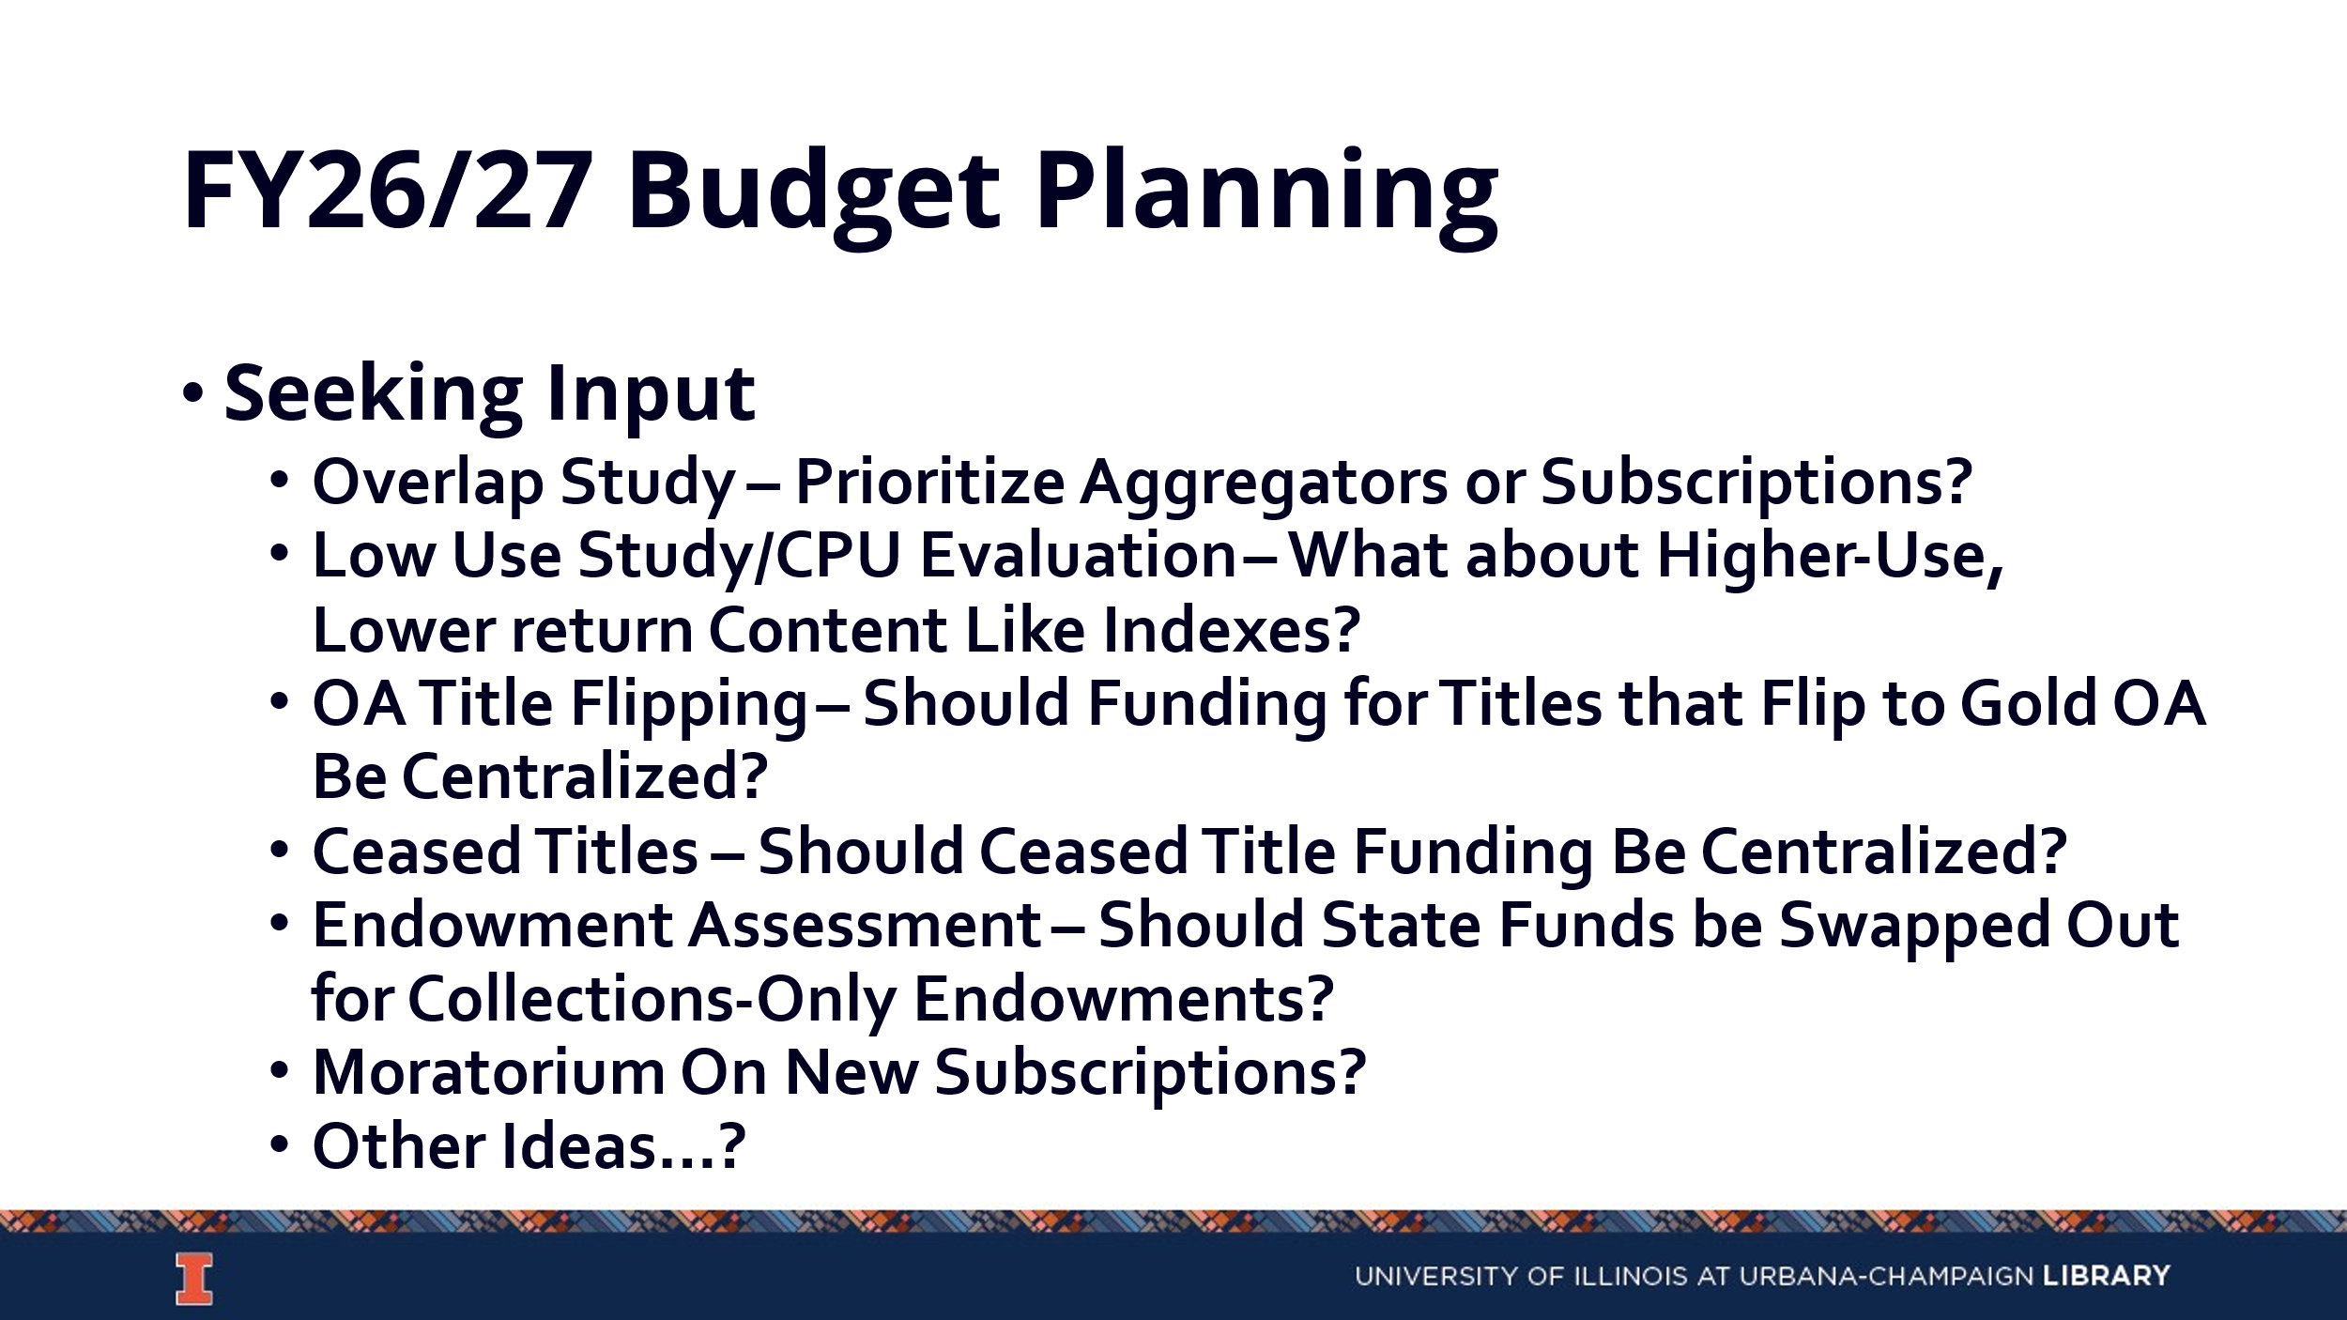

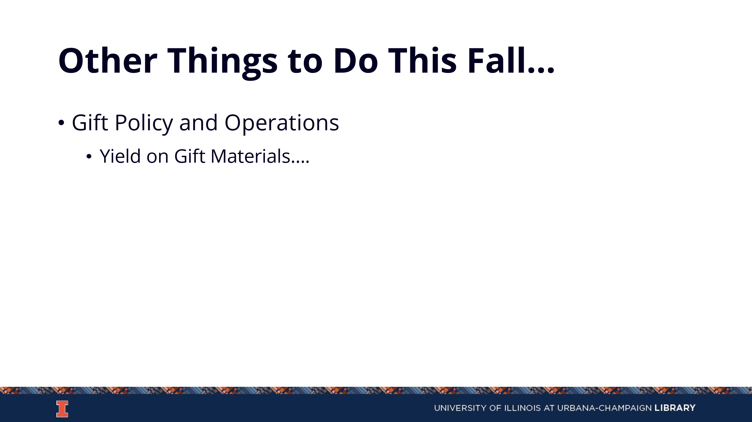
- It was suggested for Tom to potentially hold an open session for librarians to explain the budget process. Language is needed for how to communicate this information to divisions.
- We need to make the argument that we are not like every other centrally funded unit on campus. Accreditation for other units is based in part on the Library and we factor in other ways to how these departments make money.
- Our Read & Publish agreements are another way in which we save campus money. Faculty need to be aware of these issues so they can add their voices. If we have to make cuts, this should not be done behind the scenes. Input from faculty on our modeling would be beneficial.
- Some potential first steps include: putting a moratorium on new subscriptions, stopping ability to transfer money from 0 funds to 9 funds. We will need some flexibility within this.
  - A moratorium on new subscriptions would communicate the impact to a larger campus audience.
- If we quietly self-fund then it send the message that it is okay to give the Library less than what it needs and at some point the measures of self-funding will no longer work.
  - At every opportunity we need to make known that we are unable to support various programs, positions, materials, etc. If we are no longer able to support the mission of the institution, then this needs to be heard loudly on campus.
- The next few months will be a period of data gathering. We will look at cost per use, overlap, and start lining things up.

Updates
- Acquisitions The EBSCO renewal is being finished.
- E-Resources No new updates
- Preservation Services No new updates
- BTAA Updates

--

